**12 LEAD EKG INTERPRETATION LECTURE**

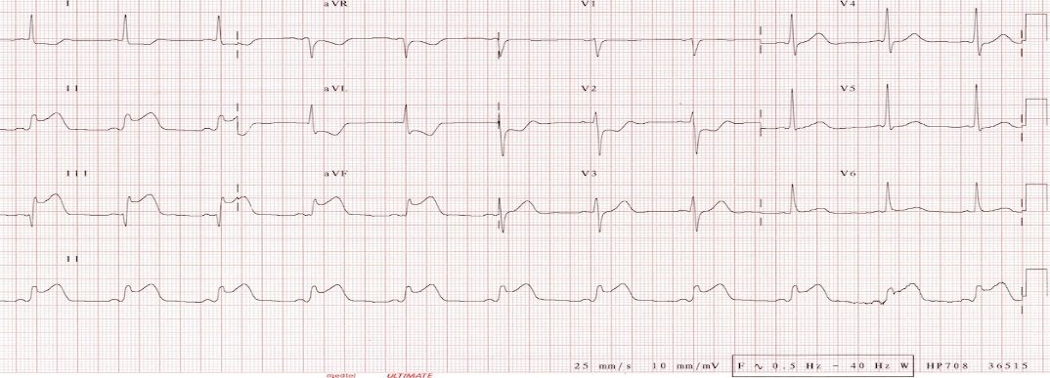

A 1 day Class, held 3 days in a row

**Where**: Anniston City Meeting Center; 1601 Noble Street, Anniston, AL 36201

**When**: January 26th, 27th & 28th at 8:30 AM – 4:00 PM

**WHY**: The lecture will cover STEMI Recognition, STEMI Equivalents and STEMI

Mimics. Proper 12 lead interpretation is essential in today’s goal of rapid

diagnosis to treatment of ACS.

**Hosted by**: The Anniston Fire Department

**Cost**: FREE !!

**Contact:** Anniston Fire Department EMS Coordinator David Conde @

(256)231-7689 or (256)282-2767 for further information.

The speaker is Fire Captain / Paramedic Tom Bouthillet with Hilton Head Island Fire Rescue. He is the Chief Content Architect of ECG Medical Training, Editor-in-Chief of EMS 12-Lead, Co-Producer of the Code STEMI Web Series, and Author of the 12-Lead ECG Challenge app. He is a member of the Editorial Advisory Board of EMS World Magazine and author of the popular EMS 12-Lead column at EMS1.com. He has taught nationally in the Critical Care Transport (CCEMT-P) program out of UMBC and his writings have been referenced in the American Heart Journal, the Journal of the American College of Cardiology: Cardiovascular Interventions and the EP Lab Digest.