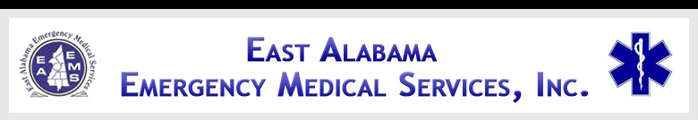

**EAST ALABAMA EMS**

Presents

***Cardiac Patients and 12-Lead EKG***

**At our 2ND FRIDAY LECTURE SERIES**

**FRIDAY, June 10, 2016**

**10:30 AM – 2:30 PM**

**Banquet Room on Ground Floor**

**Brookwood Baptist Health**

**Citizens Baptist Medical Center**

**604 Stone Ave.**

**Talladega, AL 35160**

**Sponsored by:**

**Brookwood Baptist Health**

**Citizens Baptist Medical Center**

**&**

**Northstar Ambulance-Talladega**

**OBJECTIVES**

* **Review the anatomy of the cardiovascular system;**
* **Identify early signs & symptoms of cardiac emergencies;**
* **Discuss early diagnostics and interventions;**
* **Discuss different treatment modalities;**
* **Understand the roles the pre-hospital and in-hospital providers play in early interventions.**

**AGENDA**

**1030-1035 Introductions**

**1035-1105 Anatomy Review**

**1105-1135 Signs & Symptoms**

**1135-1205 Lunch will be served**

**1205-1255 Diagnostics & Interventions**

**1255-1345 Treatment Modalities**

**1345-1425 Early Interventions**

**1425-1430 Evaluations**



**SPEAKER INFORMATION**

Derick Robinson, FP-C/RN/NR-P/CCEMT-P

Derick is a clinical base educator with AirMethods/Lifesaver. He has 15 years of prehospital EMS care experience, with 9 years of Critical Care experience as a Flight Paramedic. He is also a Registered Nurse in Emergency Department and Surgery.

There is no charge for attendance but pre-registration is strongly encouraged. 4.0 contact hours will be awarded to those who complete this program. No partial credit will be awarded. You must attend the course in its entirety to receive credit. EAEMS will be providing continuing education credits to EMT’s and nursing contact hours to nurses. East Alabama EMS is an approved provider of continuing education for nurses by the Alabama Board of Nursing. Provider Number _ABNP 1456__ expires: _08.25.2015_. Nurses must bring their current Alabama Board of Nursing license to the program to be swiped in order to receive contact hours.

**TO REGISTER OR FOR MORE INFORMATION:**

**Contact East Alabama EMS 205.763.8400 or** [**eaems@centurytel.net**](mailto:eaems@centurytel.net)